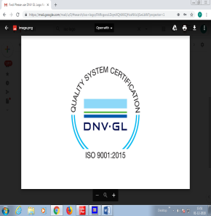**R.M.K. ENGINEERING COLLEGE**

**(An Autonomous Institution)**

RSM NAGAR, KAVARAIPETTAI – 601 206

**20CS202 - Python Programming (Lab Integrated)**

**List of Programs**

|  |  |
| --- | --- |
| **S. No.** | **Program Name** |
| 1 | GCD of two numbers |
| 2 | Square root of a number |
| 3 | Exponentiation |
| 4 | Tuple - Repeated element |
| 5 | Tuple - Slicing |
| 6 | Tuple - Reversing |
| 7 | Matrix - Replacing values |
| 8 | String - Replacing Character |
| 9 | String - Get Longest word length |
| 10 | String - Remove characters |
| 11 | String - Reversing |
| 12 | Sorting the words |
| 13 | Count the words |
| 14 | List - Largest element |
| 15 | List - Count Unique elements |
| 16 | List - Smallest element |
| 17 | Remove element |
| 18 | Remove even positioned elements |
| 19 | Second smallest number |
| 20 | Linear Search |
| 21 | Counting the numbers |
| 22 | Sort - Selection sort |
| 23 | Sort - Insertion sort |
| 24 | Sort - Merge sort |
| 25 | First N prime numbers |
| 26 | Matrix - Multiplication |
| 27 | Most frequent word |

Internal Examiner External Examiner